**BUSA 424: Business Analytics Modeling**

**Assignment 3**

**Name: Ashish Acharya**  **Date: 10/22/2023**

**Title: Understanding the Implications of Regression Analysis**

Regression analysis, a fundamental statistical tool, is employed to unravel the relationships between variables and predict outcomes. In this essay, we will dissect the results of a multiple linear regression analysis with a focus on the prediction of a dependent variable, X1, using two independent variables, X2 and X3.

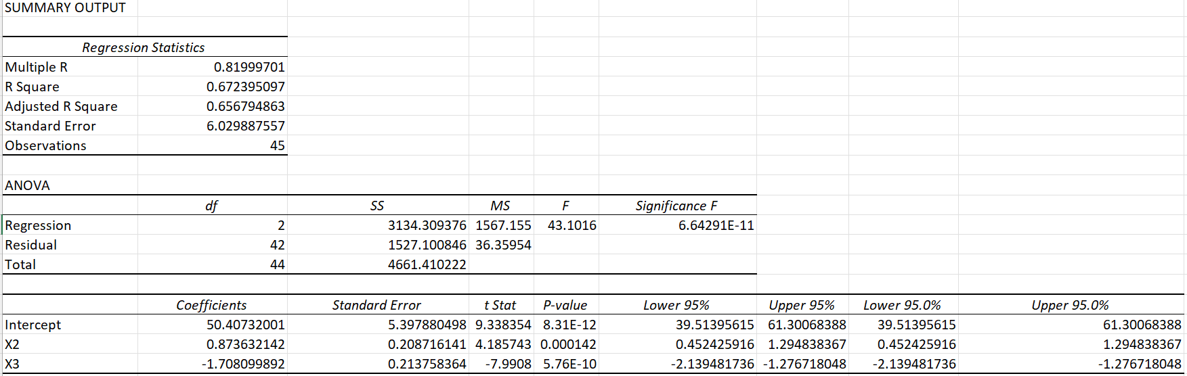

**1. Regression Statistics:**

The initial section of the analysis offers critical insights into the model's performance.

- The Multiple R (0.82) denotes a strong linear relationship between X2 and X3 with the dependent variable, X1.

- The R-squared (0.6724) indicates that around 67.24% of the variance in X1 can be explained by the model, highlighting its efficacy.

- The adjusted R-squared (0.6568) further validates the model's strength even after considering the number of predictors.

- The standard error (6.03) signifies the accuracy of the model's predictions, with lower values indicating better accuracy.

- The dataset comprises 45 observations.

**2. ANOVA:**

The ANOVA section evaluates the overall significance of the regression model.

- The F-statistic (43.1016) and the extremely low p-value (6.64291E-11) confirm that the combination of X2 and X3 is highly significant in explaining variations in X1.

**3. Coefficients:**

This section provides information about the coefficients for X2, X3, and the intercept.

- The intercept (50.41) represents the estimated value of X1 when X2 and X3 are both zero.

- X2's coefficient (0.874) indicates a positive relationship with X1, meaning that an increase in X2 leads to an increase in X1.

- X3's coefficient (-1.7081) indicates a negative relationship with X1, implying that an increase in X3 results in a decrease in X1.

The coefficients are accompanied by standard errors, t-statistics, p-values, and 95% confidence intervals, which provide insights into their significance and precision.

In summary, the regression analysis demonstrates the model's effectiveness in predicting X1 using X2 and X3. X2's positive influence and X3's negative influence on X1 are evident. The model accounts for a substantial portion (57.24%) of the variance in X1, supported by low p-values and a highly significant F-statistic. These findings empower decision-makers with valuable insights into the relationships between these variables and offer a basis for informed decision-making.